**Create an AI Assistant Using Python and OpenAI API.**

Chatgpt took the world by storm gaining users rapidly. The company behind Chatgpt , OpenAI has provided their API for accessing their models for our own uses.

Let’s use OpenAI LLM to create our own AI assistant!

**Steps:**

1. ) Create a new project and python environment.

2. ) Install dependencies including OpenAI.

3. ) Create the python script in the project folder as main.py

**Step 1.)**

Let’s first create a new folder, named story_generator and add in a python virtual environment to hold all the dependency installations that we are gonna do for this project. The use of a virtual environment is that it’ll apply the dependency installed environment only when the virtual environment you create is activated. This helps to avoid dependency conflicts which might happen when you create multiple projects on your system and do the dependency installations globally. (Yeah different projects might have different version or other dependency differences)

**create app folder in terminal:**

mkdir <app_name>

**get into the app folder using the terminal:**

*cd <app_name>*

**Create the virtual environment:**

*python3 -m venv env*

here **env** is the name we are giving to the environment we are creating, we can give any name we need.

**Next activate the virtual environment:**

*source env/bin/activate*

**Step 2.)**

Now that we have activated the virtual environment, let’s install the openai library using pip:

*pip install openai*

*pip install python-dotenv*

Dotenv is required to access the apikey in the main script from the .env file where we store the key as environment variable (helps in security of the api key)

Let’s also get the openAI api key from the openAI website : <https://platform.openai.com/>

WE can get this key by first opening the api keys option from the top left profile icon drop down.

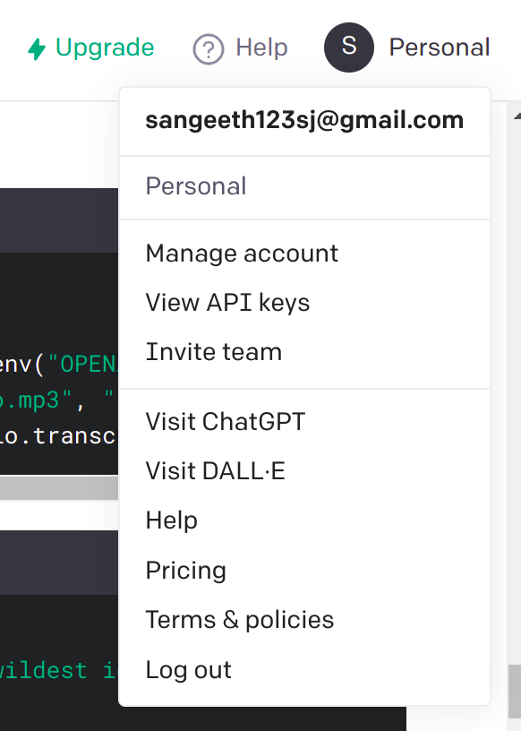

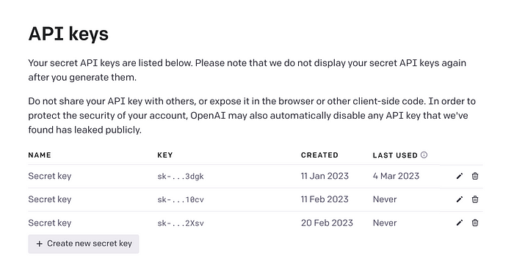

Let’s copy the api key

Then create a new file in the project folder as .env

and add it to the .env file as

OPENAI_API_KEY=<api key>

We keep the key in the .env file to avoid pushing the .env file to github and making our api key public for unauthorized access.

You can create a .gitignore file and add .env in it to avoid the .env file being pushed to github repo when connect it upto github as a repository.

**Step 3.)**

We are ready to create the script now.

import os  
import openai  
#importing dotenv to access the environment variable open ai key #from .env file  
from dotenv import load_dotenv  
load_dotenv()  
openai.api_key = os.getenv("OPENAI_API_KEY")  
#lets list the LLM models available from openai  
openai.Model.list()

the response shows the list of models available:

*{  
“object”: “list”,  
“data”: [  
{  
“id”: “model-id-0”,  
“object”: “model”,  
“created”: 1686935002,  
“owned_by”: “organization-owner”  
},  
{  
“id”: “model-id-1”,  
“object”: “model”,  
“created”: 1686935002,  
“owned_by”: “organization-owner”,  
},  
{  
“id”: “model-id-2”,  
“object”: “model”,  
“created”: 1686935002,  
“owned_by”: “openai”  
},  
],  
“object”: “list”  
}*

Now let’s modify the code to print a text completion using the LLM

import os  
import openai  
#importing dotenv to access the environment variable open ai key #from .env file  
from dotenv import load_dotenv  
load_dotenv()  
openai.api_key = os.getenv("OPENAI_API_KEY")  
  
completion = openai.ChatCompletion.create(  
 model="gpt-3.5-turbo",  
 messages=[  
 {"role": "system", "content": "You are a helpful assistant."},  
 {"role": "user", "content": "Hello!"}  
 ]  
)  
  
print(completion.choices[0].message)

The actual response we get is :  
*{  
“id”: “chatcmpl-123”,  
“object”: “chat.completion”,  
“created”: 1677652288,  
“model”: “gpt-3.5-turbo-0613”,  
“choices”: [{  
“index”: 0,  
“message”: {  
“role”: “assistant”,  
“content”: “\n\nHello there, how may I assist you today?”,  
},  
“finish_reason”: “stop”  
}],  
“usage”: {  
“prompt_tokens”: 9,  
“completion_tokens”: 12,  
“total_tokens”: 21  
}  
}*

Now let’s modify the code again to take the text input from the user using the python script.

import os  
import openai  
#importing dotenv to access the environment variable open ai key #from .env file  
from dotenv import load_dotenv  
load_dotenv()  
openai.api_key = os.getenv("OPENAI_API_KEY")  
  
#using the while loop to continously take inputs from user and  
#give responses like in a chat  
while True:  
 user_input = input("You: ") # Get user input  
  
 # Create a list of messages with the user's input  
 messages = [  
 {"role": "system", "content": "You are a helpful assistant."},  
 {"role": "user", "content": user_input}  
 ]  
  
 # Make the API call  
 completion = openai.ChatCompletion.create(  
 model="gpt-3.5-turbo",  
 messages=messages  
 )  
  
 # Print the assistant's response  
 print("Assistant:", completion.choices[0].message["content"])  
  
 # Ask whether to continue or stop  
 user_choice = input("Continue? (y/n): ")  
 if user_choice.lower() != "y":  
 print("Glad to help bye!")  
 break # Exit the loop if the user doesn't want to continue

The response on running the python script which I have saved as main.py

by using the command **python3 main.py**

You: How's the weather today?  
Assistant: The weather is sunny and warm today.  
  
Continue? (y/n): y  
You: Can you recommend a good movie to watch?  
Assistant: Certainly! I'd recommend watching "Inception." It's a mind-bending sci-fi movie.  
  
Continue? (y/n): y  
You: What's the capital of France?  
Assistant: The capital of France is Paris.  
  
Continue? (y/n): n  
Glad to help bye!

It is small steps that accumulate and lead to big projects. With this simple script, I have given you a small step. Now it’s upto your imagination and efforts to build on it. Thanks for going through and trying the tutorial, if you have any doubts, clarifications or feedbacks let me know them in the comments. Follow for more I post multiple times a week!

**In Plain English**

*Thank you for being a part of our community! Before you go:*

* *Be sure to****clap****and****follow****the writer! 👏*
* *You can find even more content at*[***PlainEnglish.io***](https://plainenglish.io/)***🚀***
* *Sign up for our*[***free weekly newsletter***](http://newsletter.plainenglish.io/)*. 🗞️*
* *Follow us on*[***Twitter***](https://twitter.com/inPlainEngHQ), [***LinkedIn***](https://www.linkedin.com/company/inplainenglish/), [***YouTube***](https://www.youtube.com/channel/UCtipWUghju290NWcn8jhyAw), and [***Discord***](https://discord.gg/GtDtUAvyhW)***.***